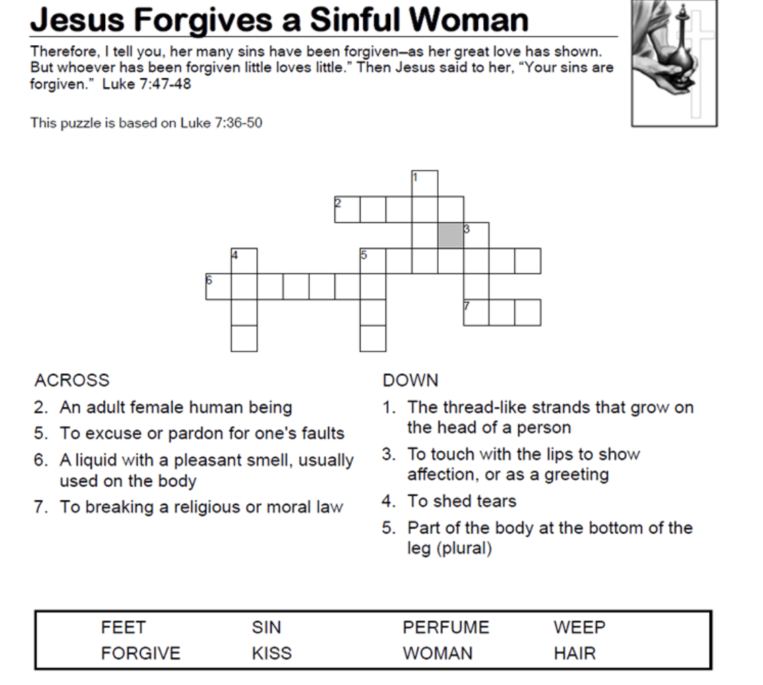

9. What is prayer? Prayer is talking with God to p_________ Him, a___ Him for help, and c_____________ our sins.
10. Write Jeremiah 29:12-13

